Name: Edward Davey
Group: 12

Personal Reflection Statement
This reflection will outline the contributions, learning, and personal development that I have had during Semester 1 trying to complete the supply and demand forecasting system for Genese Solutions as part of group 12. My role within the group was assigned to software and cloud computing, alongside group leader. This meant that I would complete an online AWS course, liaise with Genese Solution, and coordinate tasks within the group. This tested my communication, organisational, and problem-solving skills as I would need to take everyone's time difference (Genese Solution are based in Nepal) when setting up meetings between us. This reflection well discuss my contributions, lessons learned, and growth as well as how I plan to further the project during Semester 2.

My main contributions to the project so far have been communicating between us and Genese Solutions. We had weekly meetings between us and Genese Which needed to account for the difference in time zone and fit around their busy schedule. Two of the people from Genese solution I had regular contact with was Shubas and Sandesh who as a group we regularly met with. The meetings took place between November and December 2025 and can be found in the appendix section. These meetings were essential in finding the client's scope, design ideas, and getting feedback on early products before we released the minimum viable product to Genese for the client sign off. This contribution I believe demonstrates my professionalism, reliability, and engagement with the client which key skills for a team leader to have.

In addition to this I created a cloud architecture plan for when we transfer the machine learning prototype which is locally hosted onto the AWS deployment. This allowed me to take my understanding from the AWS fundamentals course I fulfilled and channel them into a real-life project. With the AWS cloud plan I had to account for costs and feasibility for a client. As a group, we chose to delay AWS deployment till Semester 2 because this meant we could develop a good machine learning model and locally host it and then from that progress put it to AWS.

I also managed online resource is like the GitHub repository and Trello work board. It was my task to take the ideas we had for the week and assign them to the different team members based on their roles within the team. This also meant I was in regular contact with each of my team members 2 let them know what tasks they had for that Sprint. Everyone in the team knew that if they needed assistance with the tasks as some people were busier than others in certain sprints they could ask for help and receive it from any of us in the team. I made many changes to the GitHub and Trello board throughout Semester 1 which can be shown in the activity of both.

One of the important lessons I learned through semester one was the AWS implementation. Before this I had no prior knowledge to AWS or how it worked so it was very important for me to learn it so that I can use my learnings for Semester 2 and have used it for the design work. Another key lesson of semester one was scope management and organisational skills when it came to what tasks to complete in a sprint. I also learned of using clear documentation through the use of GitHub, Trello, and meeting minutes to ensure that anything discussed during the meetings with the client was written down so we could refer back to it later.

The project has allowed me me to have some personal growth in my organisational and communication skills. This is due to the consistent meetings that were held between us and the client as well as being the team leader and organising which tasks to put in which Sprint and how long each one should take so I could check in with my team members if they needed help.

I have also grown in confidence when talking about cloud systems and integration. This is due to before semester one me having no knowledge of how to do a cloud computing system. I have also learned about infrastructure as code, data pipelines, and feature stores which have helped to decrease the knowledge gap between me and a graduate developer completing this project. This growth has allowed me to be more vocal in our client meetings when cloud infrastructure was the topic of conversation and I was able to explain my cloud design with confidence.

Furthermore, I have improved my ability 2 manage people in a team. Rather than focusing solely on myself it has allowed me to focus on myself and three other people and split the work by those 4 individuals rather done only one individual like every other university project.

In Semester 2 I am hoping to have a full scale cloud infrastructure develops too further the work done by the machine learning and web design engineers. I intend to take the lead role in deploying the machine learning system to AWS infrastructure. This will include data storage, model training, and automation Which will build on the prototype developed in Semester 1.

Additionally I wish to improve my documentation and reflective abilities ensuring that I can contribute to the project with professionalism and reliability.

In conclusion, after semester one I have been able to learn the AWS philosophy, importance of teamwork, planning, and professional practises in IT systems, and how to keep a professional relationship with clients. I have made meaningful contributions through client coordination, cloud architecture planning, and team management. These contributions can be supported by the evidence in the appendix below. I am confident that the foundations I have worked on during semester one will help me when it comes to doing Semester 2 starting in a few weeks time.

Appendix - Evidence
Significant Event Mentioned | Git Commit Hash/ Trello Card (deck and card)/ Meeting Minutes (date and point)
Setup all meetings between us (group 12) and Genese Solution (shubas and Sandesh). | Dates: 24/11/25 11:15-12, 1/12/25 10:30-11:30, 4/12/25 11:15-12, 8/12/25 11-12, 12/12/25 14:15-15, 15/12/25 11-12.  Evidence in the screenshot below  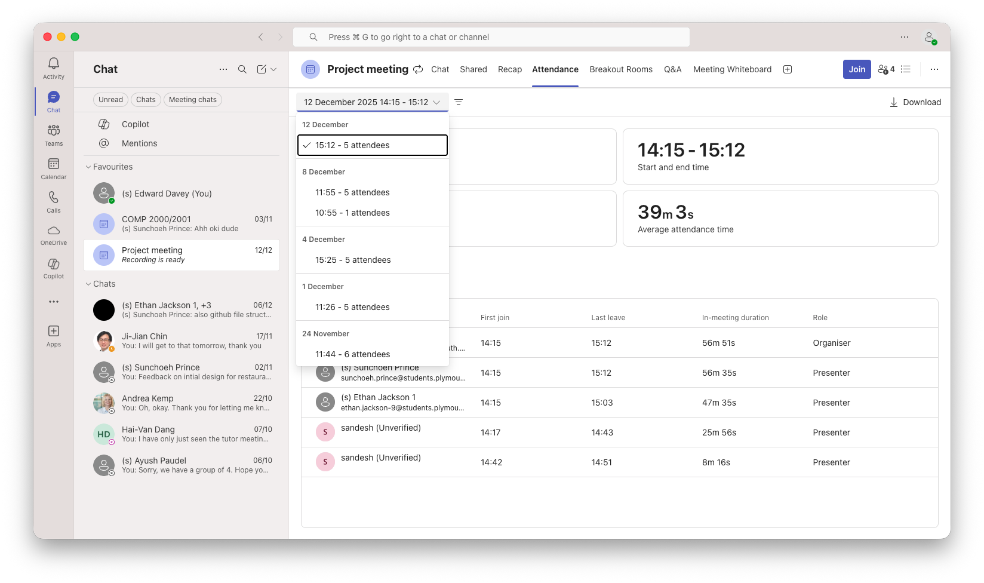
Completed AWS foundations course | Certificate for completing the course can be found on the github using the file path: main/Design Documents/Edward - data & cloud/Certificates  This file path leads to the badge and the certificate given to me by credly which I downloaded.
Liaised between us and Genese Solutions to get client sign off | 